**Employee Management interface:**

1>Below mention is the main landing page.

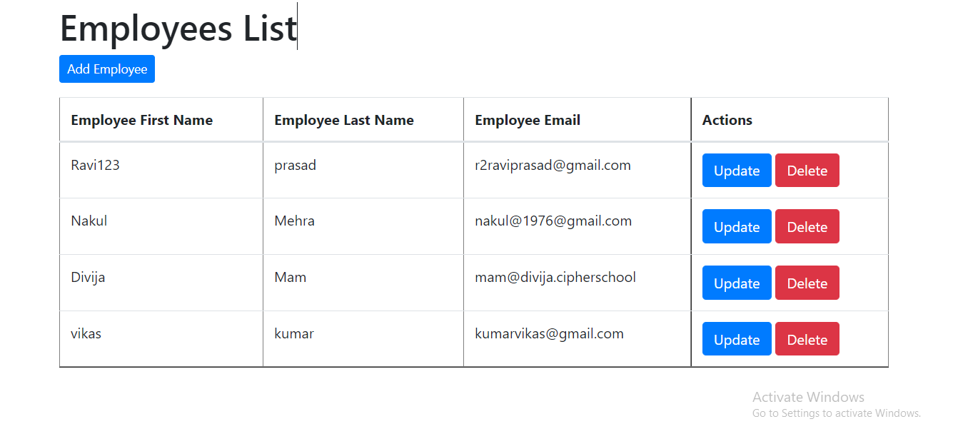

2> This is how adding employee interface looks.

3> This is the interface of updating employee.

4> This is the interface of Employee List.

